EXPERIMENT 1
8-Puzzle Problem
Question
Write a Python program to solve the 8-Puzzle problem.
Aim
To write a Python program to solve the 8-Puzzle problem using the Breadth First Search (BFS) algorithm.
Algorithm
- Start with the initial state of the 8-Puzzle.
- Represent the empty space as 0.
- Store the initial state in a queue.
- Find the position of the empty space.
- Move the empty space up, down, left, or right.
- Generate the new puzzle states.
- Store the unvisited states in the queue.
- Repeat the process until the goal state is reached.
- Display the solution path.

Code
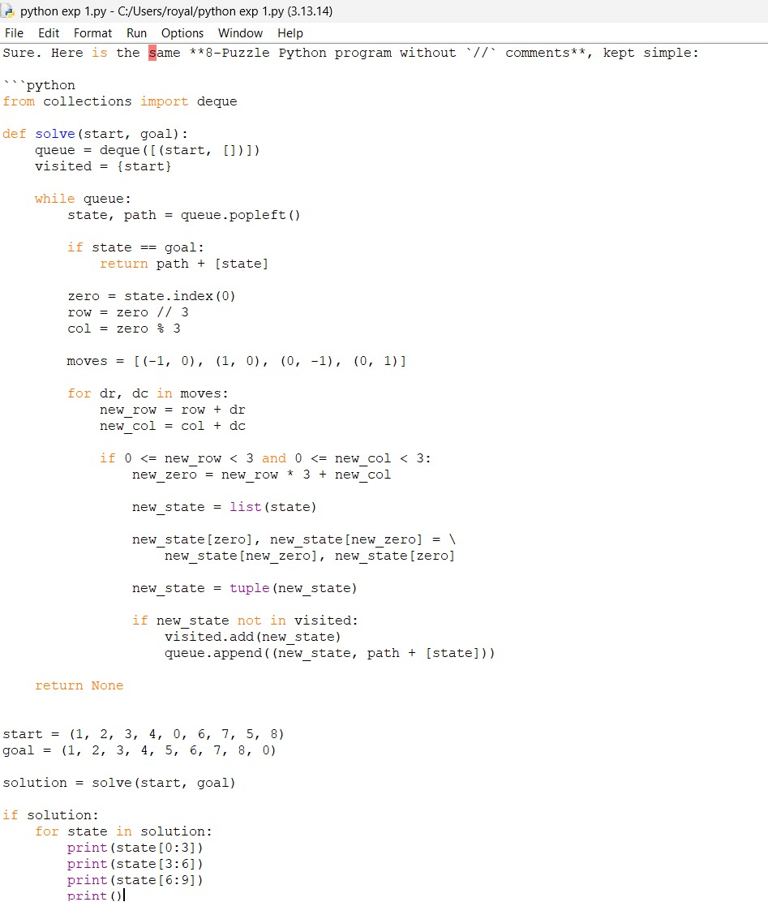

Output
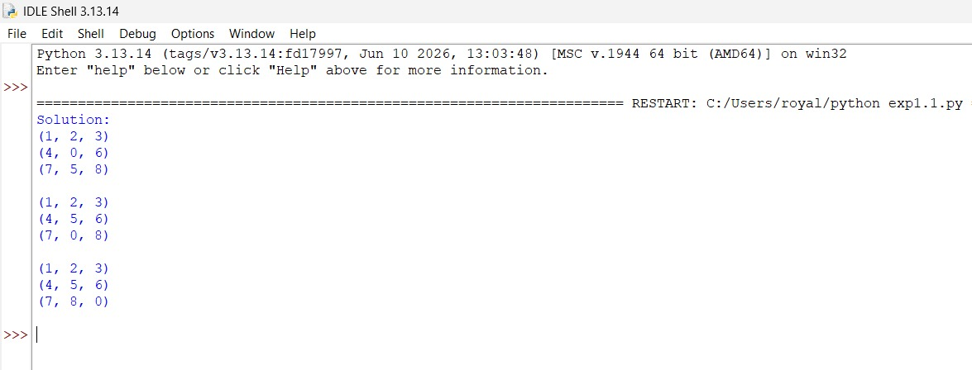

Result
Thus, the Python program was successfully executed to solve the 8-Puzzle problem, and the required goal state was obtained.

